Irmscher Opel Insignia „iS3“
Remshalden, in December 2021

Spectacular design study for the Opel Insignia in Irmscher sportswear - the luxury sedan succeeds in making a grand entrance with its extensive design elements. The Remshalden-based company has been building special vehicles and special models for more than 50 years - more than 500,000 vehicles have already been customized in Irmscher modification centers.

The top vehicles of the worldwide touring car series served as inspiration for this spectacular design. Already with the first view of the front one recognizes the clear differentiation by the aggressive front part with the complexly worked out air openings
All of which have been executed in real carbon fiber. The Irmscher radiator grille in the typical honeycomb design has been part of the Irmscher DNA for many years. On the side, you will find dynamically integrated side skirts which extend over the entire lower side area and are stylistically reflected in the rear end of the rear section. The striking rear apron, in conjunction with the drag-optimized, sweeping rear spoiler, dominates the entire rear section and effectively underscores the grand appearance. All parts are executed in carbon using motorsport-oriented methods.

Motorsport has left a lasting mark on the Irmscher history and this is clearly noticeable in the Irmscher Insignia "iS3". Countless motorsport successes by drivers such as Walter Röhrl, Jocki Kleint, Franz Engstler or even Johnny Cecotto can be felt when looking at this vehicle.

In the series Irmscher offers already since market start an extensive individualization Portfolio, so e.g. chassis optimizations, increases in output, dynamic wheel tire combinations up to 20 inches as well as very high-quality individual leather equipment and much more besides.
These wheels are in modified variant also the footwear of the Irmscher Corsa iRC.

The Irmscher Insignia "iS3" drives forward with 30 mm lowered chassis on 20 inch Irmscher Heli Star wheels in diamond polished exclusiv variant and attracts the looks magically.
As achievement Irmscher aims at 300 HP with extensive modifications.

Whether the Irmscher Opel Insignia "iS3" is realized in a small series is still open. Until then, all interested customers can already purchase the available Irmscher customizations at any Irmscher partner or directly at www.irmscher.com.

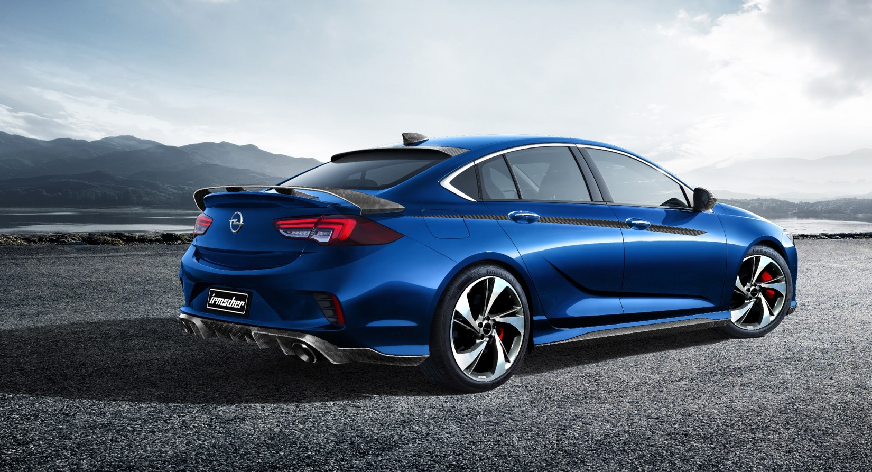
We keep all texts and images up to date and convenient for you to download:

www.irmscher.com/presse
Your access data:
User: media
Password: fotos06

